Tutorials by All Creative Designs®
www.allcreativedesigns.com.au

Picasa 5 (3.9) Photo Editing Tutorial
- How to download, install and use the Picasa Photo Editor
- How to web optimize your photos for use on the internet
Step 1: Download Picasa Software
Go to:
http://picasa.google.com/
(Copy and paste address into browser if viewing PDF version)
and click the download button.
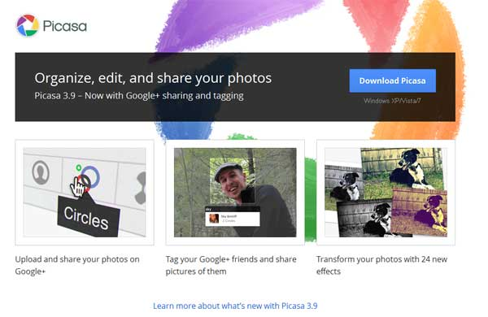

Depending on settings in your internet browser you might have to allow the file download first.
Click here for options… and then select Download File….
(See Figure 1)
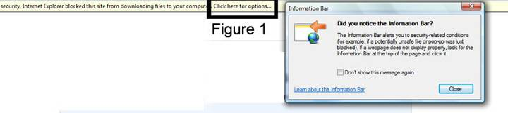

1. Click Run to download and install Picasa immediately. (Without saving a copy on your PC)
2. Click Save if you like to save a copy of the software:
(For later installation, installation on another PC without downloading the software again or as a backup etc.)
(See Figure 2)
Using Windows 7: The installation file is automatically saved to your Downloads folder.
Using Windows XP: In the file download dialog box click save and in the Save As box select a folder in My Documents to save the application. Click Save.
See Step 2.1 Installing Picasa on your computer from a saved copy.
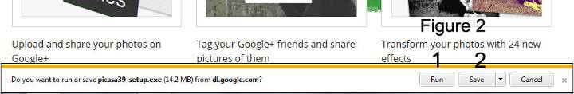

Step 2: Installing Picasa
1. Confirm the License Agreement
2. Leave destination folder as is and click Install
3. Complete setup, you might want to deselect any options not wanted. Leave Shortcut on Desktop ticked. Click Finish.
If you left Run Picasa 3 selected the program will open automatically otherwise double click Picasa shortcut icon now installed on your desktop.
(See Figure 3)

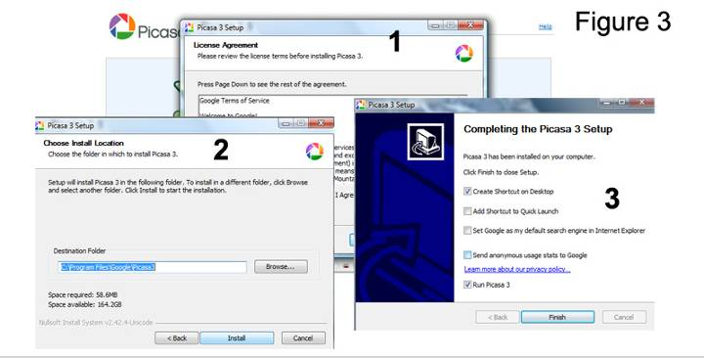

Step 2.1: Installing Picasa on your computer from a saved copy
If you haven’t started the installation immediately
1. Locate your saved picasa39-setup file and double click.
2. Click Run If Open File dialog box appears. Leave destination folder as is and click Install.
3. Confirm the License Agreement.
4. Go through the Picasa installation process and in the last window you might want to deselect any options not wanted. Click Finish.
(See Figure 3.1)
If you left the tick box Run Picasa 3 selected the program will open otherwise double click the desktop icon.

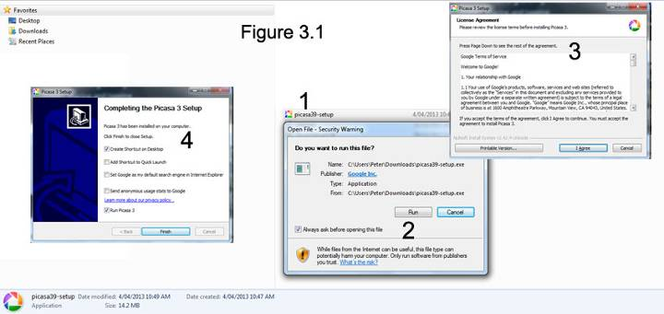

Step 3: Running Picasa the first time
Select an option for Picasa to scan your computer for images, no images will be removed from their original folders. Click Continue. (See Figure 4)
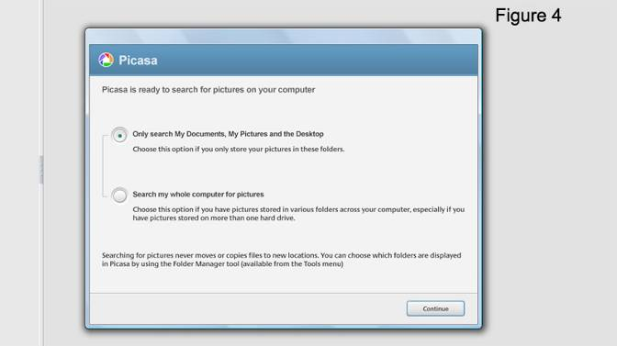

If you like to install Picasa as your default Photo Viewer select file types and click Finish. (Your default photo viewer may be Windows Picture and Fax Viewer). (See Figure 5)
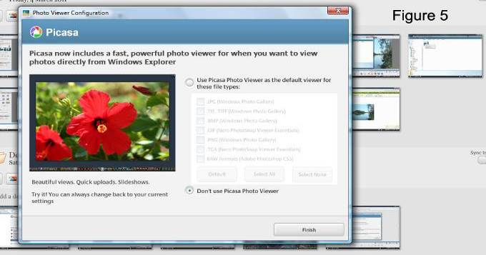
Step 4: Overview
1. The panel shows your folder structure and clicking a folder will show images contained in this folder to the right.
2. Use the button to change between flat and tree folder structure views.
3. Click Import to transfer photos from your connected camera or other folders on your PC.
4. Take instant snapshots of your web cam or other connected video devices.
5. Buttons allow you to play a slide show of images in the selected folder, create a photo collage or a video clip presentation and burn it to a disk.
6. Buttons a bottom of interface allow you to upload and share selected photos in Picasa Web Albums on the internet (Google account is necessary), email them, print them straight out of Picasa, export them and more.
7. Selecting these options will open a side panel to the right enabling you to add names to faces, show places, add a tag to a selected photo and show property information embedded in the photo.
8. To edit a photo just double click thumbnail image or right click and select edit.
(See Figure 6)

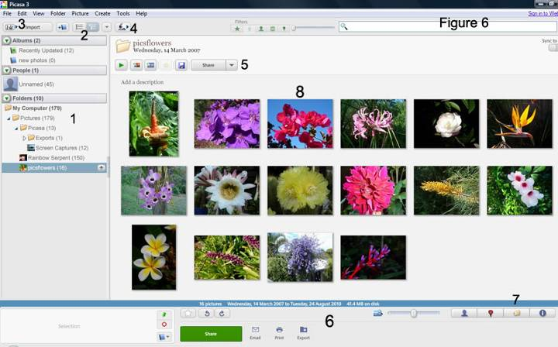

Step 5: Cropping and adjusting an image

Cropping:
- If not selected click ‘Commonly needed fixes’ than click the Crop icon.
- Under Crop Photo select Manual or the 4:3 ratio from the drop down list
Most digital cameras use this ratio. Click and drag over the area to select the portion to be cropped. For finer adjustment click and drag any corner.
- Click Apply when satisfied with the result. (See figure 7)
To reverse the cropping process after applying, click Undo Crop and try again.

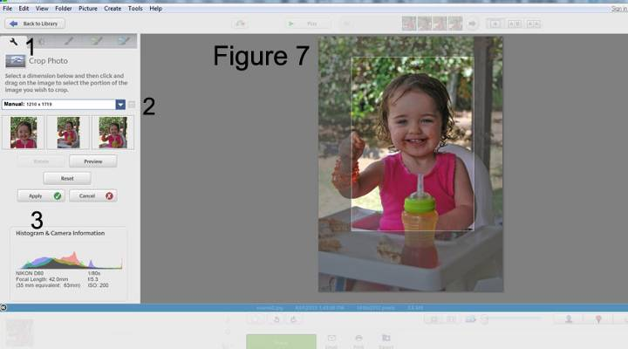

Adjusting an image:
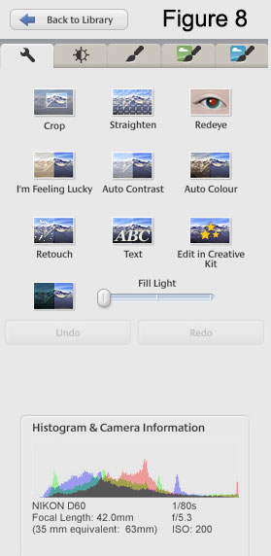

Under the ‘Commonly needed fixes’ tab

Straighten image and fix red eyes.

Try out other Auto adjustment options.

ABC Text lets you write a caption onto your image.
Edit your photo online in Creative Kit (see step 7)
Adjust the brightness with the slider
Undo and redo crop or other applied adjustments

Photo properties

See the Tuning Tab for finer adjustments and 3 Effects Tabs to apply an extended range of effects to your image.
New side by side editing:
1. By default view one image only.
2. Click to view 2 different images, use the arrows buttons to display different images out of the same picture folder.
3. Click to view the same image side by side, the example shows the edited image to the left and the original for comparison to the right.
4. Click to change the selection of the image you are working on, this example shows the selected icon above the left side image.
5. Click to change the layout to vertical, showing images above and below.
6. Click to play a slide show of all images contained in the picture folder.
7. Click to upload your image to Google Web Albums.
(See Figure 9)

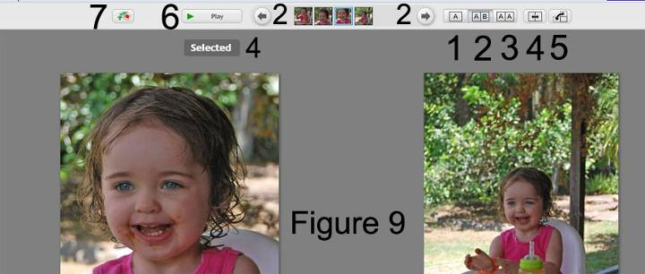
Step 6: Resizing and saving the image for the web (or other purposes)
After finishing your adjustments
1. Go to the file menu and click Export Picture to folder.
2. In the Export to Folder dialog box leave the settings under Location of exported folder as they are, this will create a root folder on your computer in My Pictures called Picasa Exports.
3. Under Name of exported folder type web_images or similar term without spaces. (If you are not resizing for web purposes call the folder as you like)
4. Select the Resize option
5. Type 400 into the white box. Picasa will keep the ratio of 4:3 when resizing. An image in portrait orientation will be 400 pixel high, an image in landscape orientation will be 400 pixel wide. Use 800 or 1200 pixels if larger sizes are required.
6. Select Custom under Image Quality and use the slider to adjust to 75 ppi. (Only select this option for web use, use automatic to keep full picture quality or other settings for images not intended for web purposes.)
7. Add a watermark if you like
8. Click Export
(See Figure 10)
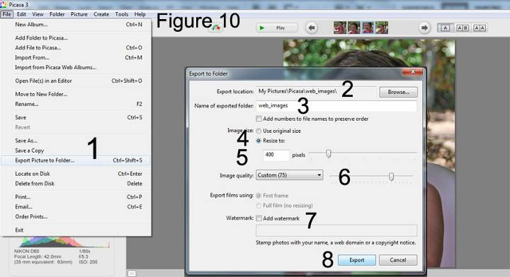
After clicking Export Picasa will open your file browser. (See next page)
From this location you can copy and paste images to your web page folder containing the index.html file (If you are preparing images to use in our web design tutorials) or any location of your choice.
(See Figure 11)
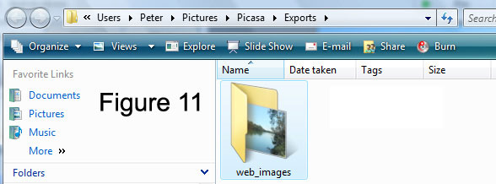
Step 6.1 Follow instructions below to create a thumbnail image of the same photo for use in your web design project.
In Picasa return to your image and go to the file menu there select Export to folder option again.
Repeat instructions in Step 6 (Figure 9) and only change 400 pixels to 150 pixels. Click Export.
Check the file size by right clicking and selecting Properties or hover your mouse pointer over the thumbnail image. In this case we compressed the 400x300 pixel image to 24 KB and the thumbnail image (150x113 pixels) to 7.84KB. (See Figure 12)
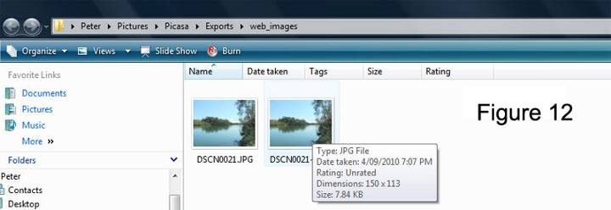
Why not use HTML resizing to insert the photo into the web page. Because HTML resizing does not compress the image file size, so inserting a 2.5 MB file into the web page will result in very slow download speeds on the internet. The goal is to create a reasonable quality image with a small file size. Only JPG, GIF and PGN file formats work on web pages.
We will have to rename the images so that they can be used in your web page. Right click the image and select Rename then type a name without spaces or special characters. Include reference to your small and large image.
Example: river_sm (indicating small size), river_fs (indicating full size)
You might like to repeat the process with another image to use in your web page.
Step 7: Edit your photo online in Creative Kit.
Select an image in Library View and double click to edit. In edit view under ‘Commonly needed fixes’ tab click Edit in Creative Kit (See figure 8). You will need a working and preferably fast internet connection. Click YES if asked to edit a copy in Creative Kit. Upload of your selected image will begin, depending on photo file size and internet connection speed this might take some time. Be aware that uploads are counted in your download limit (Bandwidth).
1. Your image will open in Creative Kit under the Basic Edits tab. Apply effects by clicking the Effect tab. To add speech bubbles, stickers, touch up, frames and more click the Decorate tab. Go to the Text tab to add text using a long list of different font types.
2. Use buttons to undo or redo changes.
3. When finished click Save to Picasa.
(See Figure 13)
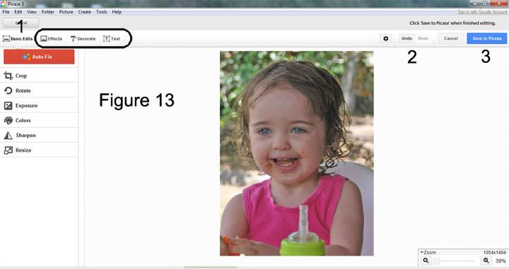

Edit functions in Creative Kit are more advanced than the one in Picasa and also give you an option to resize.
Under the Basic Edits tab select Resize. Enter new size and tick Keep Proportions click Apply.

Decide to replace or save a new copy. The finished image will be downloaded back to the Picasa library on your PC.

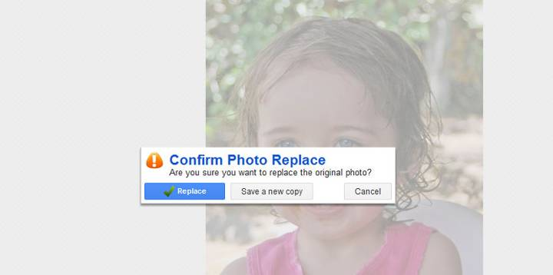

Other tutorials available from www.allcreativedesigns.com.au/pages/tutorials.html
(You might have to type or copy and paste this address into your browser if viewing the PDF version)
HTML Web Page Tutorial using Notepad, PDF Part 1
HTML Web Page Tutorial using Notepad, PDF Part 2
Free PDF HTML Tag Tutorial using Notepad Part 3
Web Design Tutorial using KompoZer, PDF
SEO Tutorial Basic Search Engine Optimization PDF
Photoshop Image Editing Tutorial

